Single Cycle CPU Design
1. Here we have a single cycle CPU diagram. Answer the following questions:
a. Name each component. (3 points)
b. Name each datapath stage and explain its functionality. (5 points)
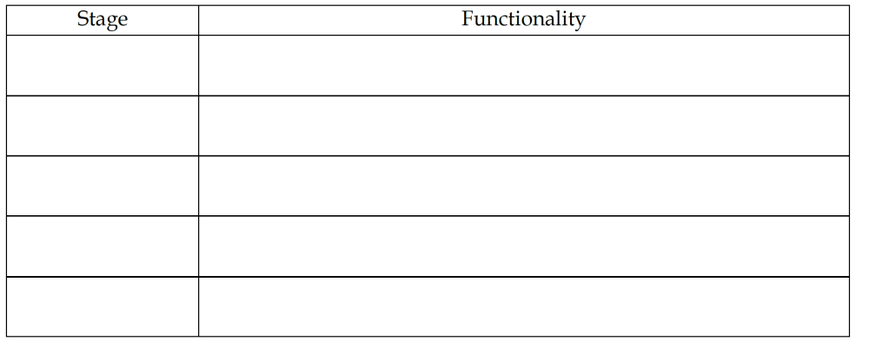
c. Provide data inputs and control signals to the next PC logic. (3 points)
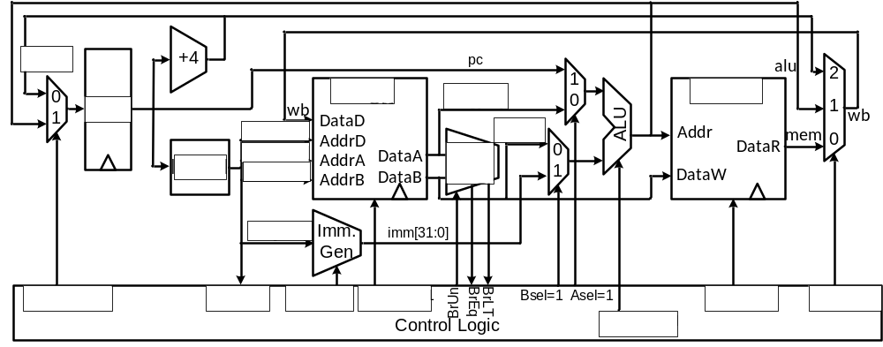
Fig. 1 Single Cycle RISC-V Datapath
Single Cycle CPU Control Logic
4. Fill out the values for the control signals from the previous CPU diagram. (8 points)
Instrs. | Control Signals
Instrs. | BrEq | PCSel | ImmSel | BrUn | ASel | BSel | ALUSel | MemRW | RegWEn | WBSel
addi
and
lw
sw
beq
jal
jalr
lui
(Put an X if the signal doesn’t matter)
Clocking Methodology
- The input signal to each state element must stabilize before each rising edge.
- Critical path: Longest delay path between state elements in the circuit.
- If we place registers in the critical path, we can shorten the period by reducing the amount of logic between registers.

Single Cycle CPU Performance Analysis
5. The delays of circuit elements are given as follows:
Stage | IF | ID | EX | MEM | WB
Delay | 200 | 100 | 200 | 300 | 100
a. Mark the stages the following instructions use and calculate the time to execute. (8 points)
Instruction | IF | ID | EX | MEM | WB | Total
Delay | 200 | 100 | 200 | 300 | 100 | -
addi
and
lw
sw
beq
jal
jalr
lui

b. Which instruction(s) exercises the critical path? (3 points)

c. What is the fastest you could clock this single-cycle datapath? (3 points)

d. Why is a single cycle CPU inefficient? (3 points)

e. How can you improve its performance? (3 points)

6. A single cycle RISCV datapath is illustrated in Fig. 1. Now we have the time information for each component tabulated in the Table below.
Element | Register clk-to-q | Register Setup | MUX | ALU | Mem Read | Mem Write | RegFile Read | RegFile Setup
Parameter | t_{clk-to-q} | t_{setup} | t_{mux} | t_{ALU} | t_{MEMread} | t_{MEMwrite} | t_{RFread} | t_{RFsetup}
Delay(ps) | 30 | 20 | 25 | 250 | 400 | 500 | 200 | 50

a. What’s the clock time and frequency of a single cycle CPU (ignore the branch comp and imm.)? (10 points)

b. If the branch comp, imm., and the control need 50 ps, 100 ps, and 250 ps, respectively. Which instructions below needs longest processing time? Please explain. (12 points)
addi, jalr, lui, lw, sw

Digital Circuit Design
10. Create an XOR gate using only NAND gates. (6 points)

11. How many different two-input logic gates can there be? How many n-input logic gates? (6 points)

12. Draw an FSM for outputting a 1 whenever we have three repeating bits as the most recent bits, a 2 whenever we have 010 or 101, and a 0 otherwise. You may not need all states. (12 points)

13. Fill out the timing diagram for the circuit below: (9 points)
+---+ +---+ +---+
IN-|D Q|-s0-|D Q|-s1-|D Q|--Out
+-^-+ +-^-+ +-^-+
| | |
CLK--+--------+--------+

clk
in
s0
s1
out

14. Fill out the timing diagram for the circuit below: (6 points)

+---+ +---+
A--|D Q|-R1-|D Q|-R2--
+-^-+ +-^-+
| |
CLK--+---|>o--+

clk
!clk
A
R1
R2

